How to set a name and a password for the wireless network
Product line: wireless question category: wireless settings
The Topology are as below:
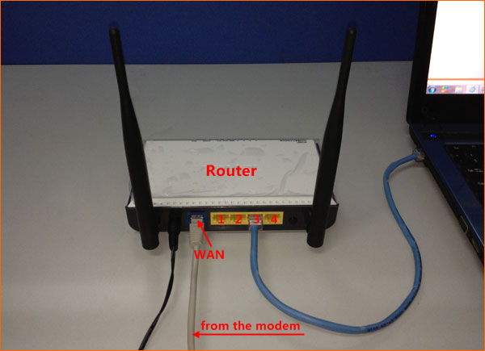

The Steps are as below:
1. Connect your computer to one of the yellow LAN port by an Ethernet cable or just connect to the router wirelessly. (It’s strong suggested that connect to the router by cable, since the wireless settings changed, the old wireless connection will drop out.)
2.Open a browser or safari, then input 192.168.0.1 in the address bar, click Enter.
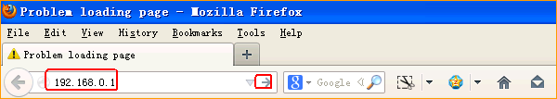

- Input the default username and password “admin, admin”, click Login to go into the homepage.
- Click WLAN Settings, then click Basic Settings, to change the SSID and then Apply.

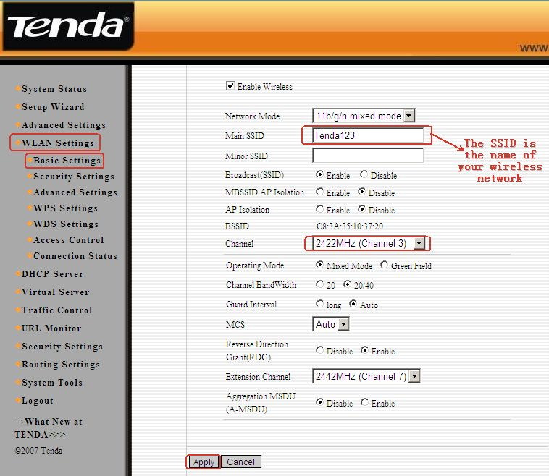
5.Click WPS Settings in the right side. Then choose Disable as WPS Settings. Don’t forget to click Save.
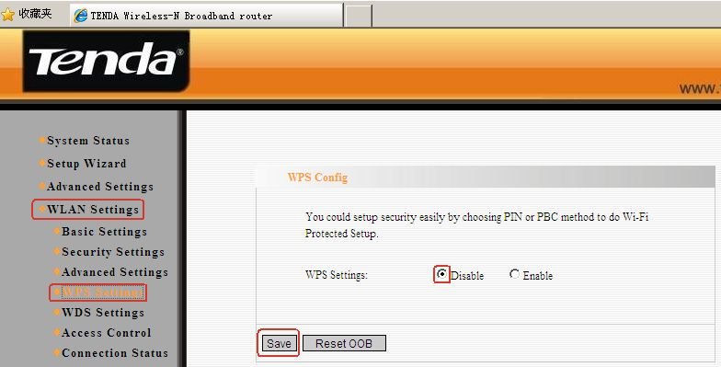

5. Click Security Settings under Basic Settings to set the wireless password as the following picture and Apply.

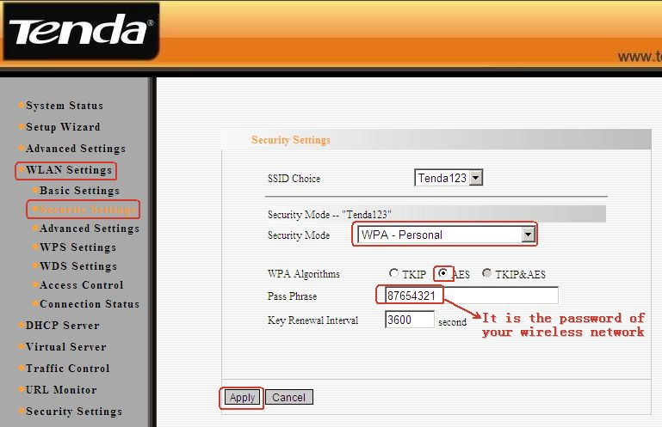

- Please find the name of your wireless network (SSID) and connect to it. It will require password, please type in the password you just created,and click OK to connect.
